**Battle of World Capitals!!!**

**Capstone Project, Coursera-IBM Specialization**

Aníbal J Guerra S, [ajguerras@gmail.com](mailto:ajguerras@gmail.com)

Medellín, Colombia

1. **Introduction**

In this project we are meant to put a lot the knowledge we have gotten through the whole IBM data science specialization. My work is intended to exhibit the application of a methodology, the usage of the right tools, data treatment, tools for visualization and to provide a final analysis that answer the initial questions.

1. **Problem Description**

I remember the days when playing the simulation game SIM City ® I could be the hero of my very own city as I designed and created a beautiful and bustling metropolis. Through a long chain of apparently simple decisions, like creating schools, libraries, hospitals, entertainment places, etc.; you could make your city a good and attractive place to live, so it would get larger and more intricate. That could be defined as success. On the opposite case, people in your town would start leaving and the whole system finally would fail. A perfect balance which sounds very hard to find.

I grew up in Latin America, in a country that we were told that we were “on the road to become a first world country”. But it always seemed like a never-ending process. After traveling a lot, and visiting very organized cities with a high standards for living, I started to ask myself: what factors really needed for a city to achieve the perfect balance that makes it attractive, providing enough quality of life to consider such city as a well developed city.

Far beyond my youthful meditations, finding the answers to such questions is a very relevant problem. For public servers in the government (i.e. major, governors) having clarity about such factors would give them clarity about the decisions that should be made to keep the city on the road to development. Two questions seem obvious: where on that road is the city right now (what does the city “have”) and what should we “have” as a city in order to be considered as developed city in the future.

As I am not an expert in such extent, I find those answers hard to find. But for sure data science has the answers. I would use the Foursquare data related to all of the venues that the capitals of the world have right now, and see if through data science I get to stratify (or cluster) those cities to see if there are specific factors that are characteristic of the cities development in each class.

Make smart choices to keep your citizens happy and your skyline growing.

Is there a magig world to be a first class perfect city ?

For a public

Estratificar los vivideros, according to a world raking

1. Data Description
2. 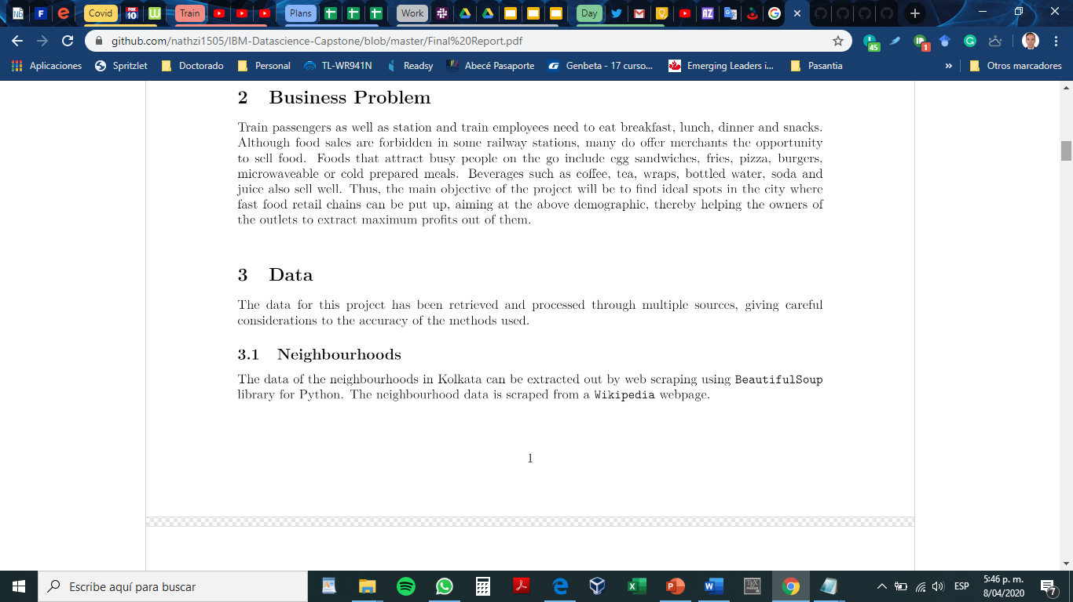
   1. Neighborhoods
   2. Geospatial data
   3. 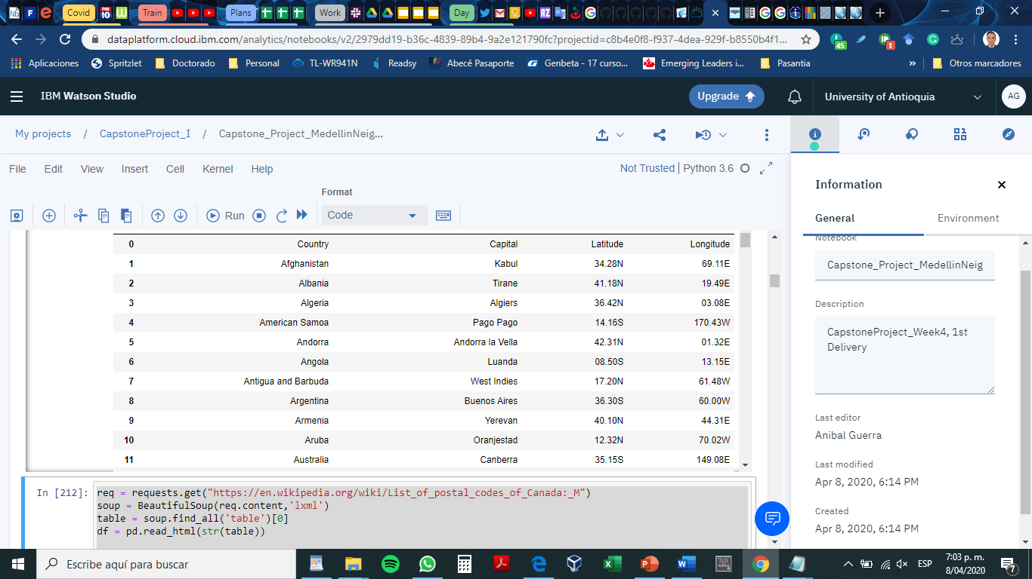
   4. Venues

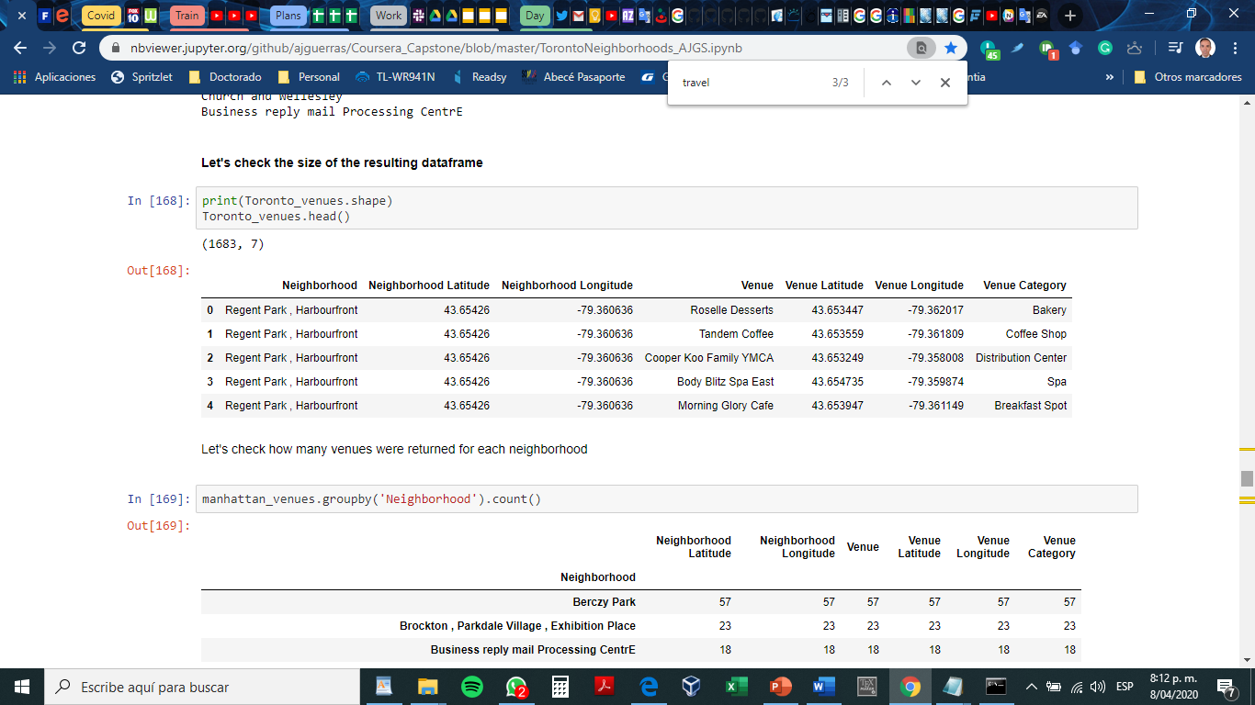

Describe the data that you will be using to solve the problem or execute your idea. Remember that you will need to use the Foursquare location data to solve the problem or execute your idea. You can absolutely use other datasets in combination with the Foursquare location data. So make sure that you provide adequate explanation and discussion, with examples, of the data that you will be using, even if it is only Foursquare location data.

This submission will eventually become your **Data** section in your final report. So I recommend that you push the report (having your **Data** section) to your Github repository and submit a link to it.

Is it possible discriminate groups of cities according to the amount of venues in them ?

Does such grouping corresponds to any known classification ? i.e developed , non-developed , or in development way.

Venues Categories:

a.- Airport: has the word “airport”

b.- Food services: Restaurant, coffee,

c.- Culture: Art, Museum

d.- Bank: Bank

e.- Spectacles, and big events: Stadium, Theater, hall

f.- Shops: Store, shop, boutique, market

g.- education services: College

h.- Tourism: travel

g.- Entertainment, Activities, leisure: Trail, Gym, club, music, pool, park, playground, plaza,

h .- lodging services : hostel, hotel,

i.- Technological services: IT services

j.- Transport facilities: train , transportation, gas station

k.- Health services: hospital, pharmacy